Keep in mind 2 caveats警告 as you review the issues that lead to effective teams:

1. Teams differ in form and structure.

* Since the model we present attempts to generalize across all variety of teams, you need to be careful not to rigidly严格的 apply the model’s predictions to all teams. The model should be used as a guide, not as an inflexible prescription不可转变的惯例。

1. The model assumes that it’s already been determined that teamwork is preferable over individual work.
   * Creating “effective” teams in situations in which individuals can do the job better is equivalent to solving the wrong problem perfectly.

Harming your team:

1. **Refuse** **to** **share** issues and concerns.
   1. Team members refuse to share information and engage in silence, avoidance, and meetings behind closed doors where not all members are included.
2. **Depend** too much **on** **the** **leader**.
   1. Members rely too much on the leader and don’t carry out their responsibilities.
3. **Fail** **to** **follow** **through坚持到底** on decisions.
   1. Teams do not take action after decision making, showing that the needs of the team have low priority优先级, or members are not committed to决心从事 the decisions that were made.
4. **Hide conflict.** 
   1. Team members don’t reveal that they have a difference of opinion, and this causes tension紧张，不安.
5. **Fail at conflict resolution.** 
   1. Infighting内讧, put-downs羞辱, and attempts to hurt other members damage the team.
6. **Form subgroups.** 
   1. The team breaks up into smaller groups that put their needs ahead of the team as a whole.

Context

* Teams can require a great deal of maintenance to function properly.
* They need management support as well as an organizational structure that supports teamwork.
* 4 contextual factors that appear to be most significantly related to team performance:
  1. Adequate resources充足的资源
  2. Leadership and structure
  3. Climate of trust
  4. Performance evaluation表现评估 and reward syste奖励系统 that reflects team contributions贡献.

Adequate Resources

* All work teams rely on resources outside the team to sustain维持, 支撑 them.
  + A scarcity of resources directly reduces the ability of a team to perform its job effectively.
* One of the most important characteristics of an effective work group is the support the group receives from the organization.
  + This support includes:
    - technology
    - adequate staffing充足的人员
    - administrative assistance行政助理
    - encouragement鼓励
    - timely information及时的信息
* Teams must receive the necessary support from management and the large organization if they are going to succeed in achieving their goals.

**Leadership and Structure.**

* Leadership plays a crucial role in the development and success of teams.
* The role of team leader involves the following:
  + Creating a real team rather than a team in name only
  + Setting a clear and meaningful direction for the team’s work
  + Making sure that the team structure will support its working effectively
  + Ensuring that the team operates within a supportive organizational context
  + Providing expert coaching
* There are some practical problems that must be resolved when a team first starts working together.
  + Team members must agree on:
    - Who is to do what (ensure that all members contribute equally in sharing the workload. )
    - How schedules will be set
    - What skills need to be developed
    - How the team will resolve conflicts
    - How the team will make and modify decisions
  + Agreeing on the specifics of work and how they fit together to integrate individual skills requires team leadership and structure.
    - Incidentally, this can be provided directly by management or by the team members themselves.
  + Although in self-managed teams, team members absorb many of the duties typically assumed by managers, a manager’s job becoming *outside* (rather than inside) the team.
* Multi-team system – Systems in which different teams need to coordinate协调,配合 their efforts to produce a desired outcome.
  + Leaders need to empower teams by delegating responsibility to them
  + Leaders need to play the role of facilitator, making sure the teams are coordinating their efforts so that they work together rather than against one another.
* Recently researchs suggest that women may make better team leaders than men.
  + In predominantly female teams, women shared leadership roles and were more egalitarian平等主义的 in how they worked.
  + Male-led teams, whether they were predominantly male groups or mixed-gender groups, received poor grades on their projects than teams where women shared leadership roles.
  + In a creative project team, it’s really important to ensure there is equal opportunity for participation.
* Sometimes teams need coaches more than they need leaders.
  + Productivity-related coaching may help teams perform more effectively.
  + In particular, coaching may be best at 3 particular stages in the team’s history:
    - At the beginning for effort-related (motivational) interventions
    - Near the midpoint for strategy-related (consultative) interventions
    - At the end of a task cycle for (educational ) interventions that address knowledge and skill.
* Teams don’t always need a leader.
  + The evidence indicates that self-managed work teams often perform better than teams with formally appointed leaders.
  + Leaders can also obstruct high performance when they interfere with self-managed teams.
  + On self-managed teams, team members absorb many of the duties typically assumed by managers.

Climate of Trust

* Members of effective teams trust on another.
  + For team members to achieve a climate of trust, they must:
    - Feel that the team is capable of getting the task done
    - Believe that “the team will not harm the individual or his or her interests”.
  + Interpersonal trust among team members
    - facilitates cooperation
    - reduces the need to monitor one another’s behavior
    - bonds members around the belief that others on the team will not take advantage of them.
* Team members are more likely to take risks and expose vulnerabilities when they believe they can trust others on their team.
* Team members must also trust their leaders.
  + Trust in leadership is important in that it allows the team to be willing to accept and commit to their leader’s goals and decisions.
* Building trust

(the following actions, in order of importance, help build one’s trustworthiness可信度.)

1. **Integrity** 正直 – built through **honesty** and **truthfulness坦率,正当**.
2. **Competence**能力 – demonstrated by technical and interpersonal **knowledge** and **skills**.
3. **Consistency一致性** – shown by **reliability**可靠性, **predictability**可预测性, and **good** **judgment** in handling situations.
4. **Loyalty** – one’s willingness to **protect** and **stand** **up**拥护for another person.
5. **Openness** – one’s willingness to **share** **ideas** and **information** freely.

Performance Evaluation and Rewards

* Individual performance evaluations, fixed hourly wages, individual incentives, and the like诸如此类 are not consistent with the development of high-performance teams.
  + So in addition to evaluating and rewarding employees for their individual contributes
  + Management should consider group-based appraisals, profit sharing, gainsharing, small-group incentives, and other system modifications that will reinforce team effort and commitmenet.
* Managers need to carefully consider the balance between paying on the basis of group performance and the level of trust among team members.
  + When team members did not trust their colleagues’ ability, honesty, and dependability, they preferred individual-based rewards rather than team-based rewards. Even when trust improved over time from working together, there was still a preference for individual-based rewards
  + Teams must have a very high level of trust for members to truly embrace信奉 group-based pay.
* One additional consideration when deciding whether and how to reward team members is the effect of pay dispersion差距 on team performance.
  + When there is large discrepancy in wages among group members, collaboration is lowered.
  + Teams in which players were paid more similarly often outperformed teams with highly paid “stars” and lowly paid “scrubs”.

Composition 构成

This category includes variables that relate to how teams should be staffed.

In this section, we address:

* Skills
* Personality
* Roles of team members
* The diversity and size of the team
* Members’ performance for teamwork

Skill

To perform effectively, a team requires 3 different types of skills:

1. It needs people with *technical* *expertise*专业技术.
2. It needs people with the *problem-solving* and *decision-making* skills to be able to identify problems, generate alternatives, evaluate those alternatives, and make competent能胜任的 choices.
3. It needs people with good listening, feedback, conflict resolution, and other *interpersonal* *skills*.

* No team can achieve its performance potential without developing all 3 types of skills.
  + The right mix is crucial. 合适的组合是至关重要的
  + Too much of one at the expense of others will result in lower team performance.
  + However, teams don’t need to have all the complementary补充的 skills in place at the beginning.
  + It’s common for one or more members to take responsibility to learn the skills in which the group is deficient不足的. Thereby allowing the team to reach its full potential.

Some important teamwork skills that help teams function well:

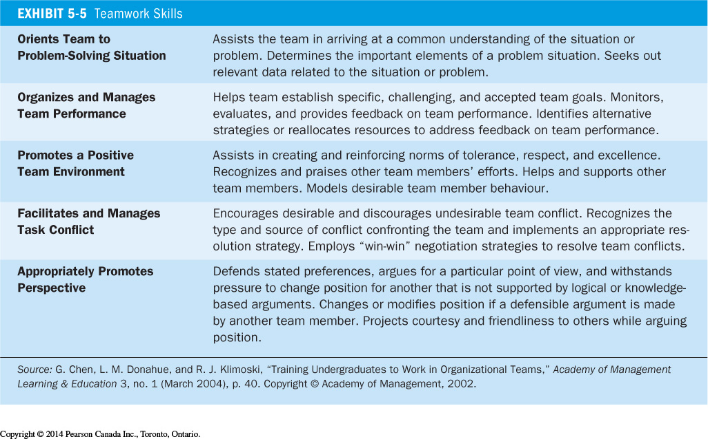

Personality

* Teams have different needs, and people should be selected for the team on the basis of their personalities and preference, as well as the team’s needs for diversity and specific roles.
* Personality has a significant influence on not only individual employee behavior but also team behavior.
* Many of the dimensions identified in the Big Five Personality Model have been shown to be relevant to team effectiveness.
  + Teams that rate higher on mean level of conscientiousness and openness to experience tent to perform better.
  + The level of team member agreeableness also matter: teams did worse when they had one or more highly disagreeable members.
* Why these 3 personality traits are important to teams?
  + Conscientious people are valuable in teams because they are good at backing up支持,援助 other team members, and they are also good at sensing感觉 when that support is truly needed.
  + Open team members communicate better with one another and throw out more ideas, which leads teams composed of open people to be more creative and innovative创新的.

Roles

* Teams have different needs, and members should be selected to ensure all the various roles are filled.
* Role – A set of expected behaviours of a person in a given position in a social unit.
* Assigning roles appropriately is very important:
* As you might expect, teams with more experienced and skilled members performed better.
* However, the experience and skill of those in core roles who handle more of the workflow工作流程 of the team, and who are central to all work process, were especially vital.
* Put your most able, experienced, and conscientious workers in the most central roles in a team.
* Within almost any group, 2 sets of role relationships need to be considered:
  + Task-oriented roles
  + Maintenance roles
* Task-oriented roles – Roles performed by group members to ensure that the tasks of the group are carried out被执行.
  + Initiators发起者, information seekers, information providers, elaborators详尽阐述者, summarizers, consensus makers共识制造者.
* Maintenance roles – Roles performed by group members to maintain good relations within the group.
  + Harmonizers协调者, compromisers调停员, gatekeepers信息传递者,门卫,捍卫者, encouragers.
* Effective teams maintain some balance between task orientation and maintenance of relations.

A number of task-oriented and maintenance behaviours in the key roles that may find in a team:

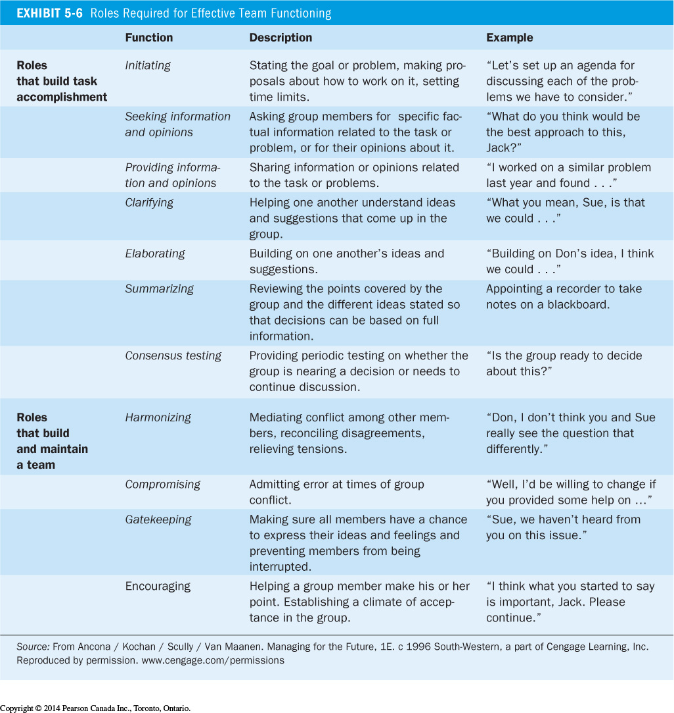

* On many teams, there are individuals who will be flexible enough to play multiple roles and/or complete one another’s tasks.
  + This is an obvious plus to a team because it greatly improves its adaptability and makes it less reliant on any single member.
  + Selecting members who themselves value重视 flexibility灵活性, and then cross-training them to be able to do one another’s jobs, should lead to a higher level of team performance over time.
* Individual roles – Roles performed by group members that are not productive for keeping the team on task.
  + When this happens, the individual is demonstrating more concern for himself or herself than the team as a whole.
* Role expectations – How others believe a person should act in a given situation.
  + Most roles, whether in the workplace or in personal lives, are governed by role expectations.
* Role conflict – A situation in which an individual finds that complying with遵守,照做 one role requirement may make it more difficult to comply with another.
  + At the extreme, it can include situations in which two or more role expectations are mutually contradictory矛盾的.

Diversity

* Group diversity – The presence存在 of a heterogeneous多样化的 mix of individuals within a group.
  + Individuals can be different not only in functional characteristics功能特性 (jobs, positions, expertise专业知识, or work experiences), but also in demographic人口的 or cultural characteristics (age, race, sex, and citizenship).
* Many of us hold the optimistic view that diversity should be a good thing:
  + Diverse teams should benefit from differing perspectives and do better.
  + However, 2 meta-analytic reviews of the research literature show that demographic diversity is essentially unrelated to team performance overall.
    - One qualifier限定语 is that gender and ethnic diversity have more negative effects in occupations职业 dominated by white or male employees.
    - But in more demographically人口地 balanced occupations, diversity is less of a problem.
  + Diversity in function and expertise are positively related to group performance, but these effects are quite small and depend on the situation.
* One of the pervasive普遍的 challenges with teams is that while diversity may have real potential benefits, a team is deeply focused on commonly held information.
* But to realize their creative potential, diverse teams need to focus not on their similarities but on their differences.
* Some evidence suggests that when team members believe others have more expertise, they will work to support those members, leading to higher levels of effectiveness.
* The key is for members of diverse teams to communicate what they uniquely know and also what they don’t know.
* Proper leadership can also improve the performance of diversity teams.
  + When leaders provide an inspirational common goal for members with varying types of education and knowledge, teams are very creative.
  + When leaders don’t provide such goals, diverse teams fail to take advantage of their unique skills and are actually less creative than teams with homogeneous均匀的 skills.

Size

* Generally speaking, the most effective teams have 5 – 9 members.
* Experts suggest using the smallest number of people who can do the task.
  + Unfortunately, there is a tendency for managers to make teams too large.
    - While a minimum of 4 or 5 members may be necessary to develop a diversity of views and skills, managers seem to seriously underestimate低估 how coordination problems can dramatically increase as team members are added.
    - When teams have excess members, cohesiveness and mutual accountability decline, social loafing increase, and more and more people do less talking compared with others.
  + So, in designing effective teams, managers should try to keep the number of members at less than 10.
    - If a work unit is larger and you want a team effort, consider breaking the unit into subteams.
      * An uneven奇数 number of members in a team provides a mechanism to break ties and resolve conflicts化解矛盾
      * An even number of members may foster培养 the need to create more consensus共识.
* Size and Social loafing社会惰化
  + Social loafing – The tendency of individuals to expend less effort when working collectively than when working individually.
    - It directly challenges the logic that the productivity of the team as a whole should at least equal the sum of the productivity of each individual in that team.
    - Research looking at teams working on a rope-pulling task showed that the larger the team, the less individual effort expended.
      * One person pulling on a rope alone exerted an average of 63 kilograms of force.
      * In groups of 3, per-person force dropped to 53 kilograms.
      * In group of 8, it fell to only 31 kilograms per person.
    - What causes this social loafing effect?
      * It may be due to a belief that others in the team are not carrying their fair share. If you view others as lazy or inept无能的, you can reestablish equity by reducing your effort.
      * The dispersion离差 of responsibility. Because the results of the team cannot be attributed归因 to any single person, the relationship between an individual’s input and the team’s output is clouded.
      * In conclusion, there will be a reduction in efficiency when individuals believe that their contribution cannot be measured.
    - To reduce social loafing, teams should not be larger than necessary and individuals should be held accountable for their actions.

Members’ Preference for Teamwork

Not every employee is a team player.

* When people who would prefer to work alone are required to team up, there is a direct threat to the team’s morale.
  + This suggests that, when selecting team members, individual preferences should be considered, as well as abilities, personalities, and skills.
  + High-performing teams are likely to be composed of people who prefer working as part of a team.

Work Design

* Effective teams need to work together and take collective responsibility to complete significant tasks.
* They must be more than a “team-in-name-only”
* The work design category includes variables:
  + Freedom and autonomy
  + The opportunity to use a variety of skills and talents
  + The ability to complete a whole and identifiable task or product
  + The participation in a task or project that has a substantial impact on others.
* The evidence indicates that these characteristics enhance member motivation and increase team effectiveness.
* These work design characteristics motivate teams
  + Because they increase members’ sense of responsibility for and ownership of the work
  + Because they make the work more increasing to perform.
* These recommendations 推荐 are consistent with the job characteristics model we presented in Chapter 4.

Process

Process variables make up the final component of team effectiveness.

* The process category includes:
  + Member commitment to a common purpose
  + Establishment of specific goals
  + Team efficacy团队功效
  + Shared mental models思维模式
  + A managed level of conflict
  + A system of accountability.
* These variables变量 will be especially important in larger teams, and in teams that are highly interdependent.
* Why are processes important to team effectiveness?
  + Social loafing indicates that when each member’s contribution is not clearly visible, individuals tend to decrease their effort. In other words, social loafing illustrates a process loss from using teams.
    - But teams should create outputs greater than the sum of their inputs, as when a diverse group develops creative alternatives.
* Scientists often work in teams because they can draw on利用 the diverse skills of various individuals to produce more meaningful research than could be generated by all the researchers working independently – that is, they produce positive synergy协同作用, and their process gains exceed their process losses.

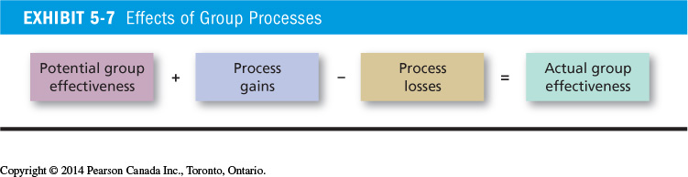

Common Purpose 共同目标

* Effective teams begin by analyzing team’s mission, developing goals to achieve that mission, and creating strategies for achieving the goals.
* Teams that establish a clear sense of what needs to be done and how consistently perform better.
* Members of successful teams put a tremendous巨大的 amount time to them both collective and individually.
* This common purpose, when accepted by the team, becomes the equivalent of what celestial navigation is to a ship’s captain – it provides direction and guidance under any and all conditions.
  + Like a ship following the wrong course, teams that don’t have good planning skills are doomed;
  + Perfectly executing the wrong plan is a lost cause.
* Effective teams also show reflexivity.
  + Reflexivity – A characteristic of effective teams, allowing teams to reflect on and adjust their master plan when necessary.
  + A team has to have a good plan, but it also has to be willing and able to adapt when conditions call for it.

Specific goals

* Successful teams translate their common purpose into specific, measurable, and realistic performance goals.
  + Goals not only lead individuals to higher performance, but also energize激励 teams.
  + Clear communication and also help teams maintain their focus on achieving results.
* Difficult goals have been found to raise team performance on those criteria for which they are set.
  + Goals for quantity tend to raise quantity
  + Goals for speed tend to raise speed
  + Goals for accuracy tend to raise accuracy

Team Efficacy团队效能

Efficacy – Effective teams have confidence in themselves. They believe they can succeed.

* Teams that have been successful raise their beliefs about future success which, in turn, motivates them to work harder.
* Cohesiveness – The degree to which team members are attracted to one another and motivated to stay on the team.
  + Though teams differ in their cohesiveness, it is important because it has been found to be related to team’s productivity.